Article template for the 11th MechMan symposium WORD
Leave as is.
Author’s Initials followed by Surname
Underline presenter name
A. Jensen, B. Hansen, C. Pedersen

Department of Materials and Production, Aalborg University
Fibigerstraede 16, DK-9220 Aalborg East, Denmark
Email: correspondingauthor@student.aau.dk,
web page: http://www.mechman.mp.aau.dk/

Abstract
In this project

Keywords: keywords list (no more than 7)

1 General Introduction
The submitted article will be used as a part of the student symposium Mechman and for reviewing the presentation quality.
The length for the paper should be no more than 10 x A4 pages, including pictures and diagrams, which may be produced in color, but should also reproduce clearly in black and white. The paper will be in A4 size with margins of top 36 mm, left and right 17.5 mm, bottom 22 mm. A column separation of 10 mm is used. The text should be Times or Times New Roman with 11 point size, with the exception of the title of the paper which must be 16 point Arial, bold, and the name and affiliation of the authors which must be 12 point Times or Times New Roman.
2 Preparation and Submission
2.1 Use of Templates
The paper shall be prepared using this supplied template. The prescribed tool is:
Preparation in Microsoft Word and submission in PDF.
The paper should conform in appearance to this example. After its completion, the author shall convert it to a PDF format.
2.2 General Procedures for Submission
The final PDF of your paper must be submitted from our official website link:
http://www.mechman.mp.aau.dk/call-for-abstracts/

The file name should have the following pattern:
GroupNumber_Study_year.pdf. e.g. 2216_DMS2_2023.pdf
It is essential that the paper be well checked with caution before submission. After the deadline date, no submissions will be accepted.

Furthermore, the paper must be handed in together with the appendix report.
2.3 Software Used and Final Paper Format
The abstract must be submitted in PDF format. No other format will be accepted.
2.4 Tables, Diagrams and Figures
Figures will either be entered in one column or two columns and should be 80 mm or 170 mm wide, respectively. A minimum line width of 1 point is required at actual size. Annotations should be in 10 point with only the first letter capitalized. The figure caption should be preceded by ‘Fig.’ followed by the figure number. For example, ‘Fig. 2. The elastic properties……’.
2.5 Photographs and illustrations
Authors should recognize that all photographs and illustrations may be produced in color, but should also reproduce clearly in black and white. Image files should be optimized to minimize size without compromising the quality. The figures should have a resolution of 300 dpi.
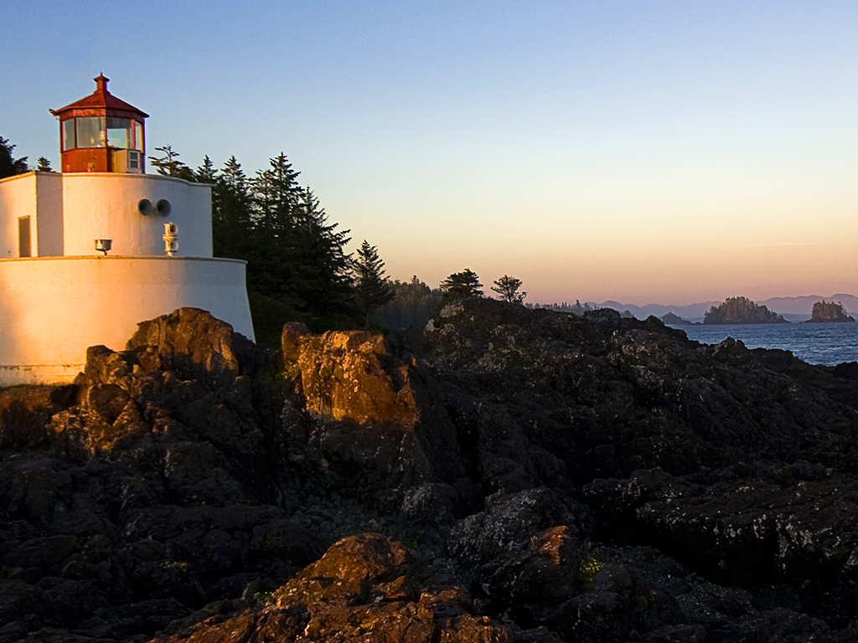
Fig.1. All figures and tables must have a caption.

2.6 Equations
Using the appropriate editor, each equation should occur on a new line with uniform spacing from adjacent text as indicated in this template. The equations, where they are referred to in the text, should be numbered sequentially and their identifier enclosed in parenthesis, right justified. The symbols, where referred to in the text, should be italicized. Symbol font may be used for Greek letters.
F=(vm+pA) | (1)
3 General Style Preferences
3.1 Style of Writing
Abbreviations should be spelt out in full the first time they appear and their abbreviated form included in brackets immediately after. Words used in a special context should appear between single quotation marks the first time they appear.
3.2 Paper Length / File Size
The paper should be no more than 10 pages including everything.

3.3 References
3.3.1 Description
The papers in the reference list must be cited in the text. In the text, the citation should appear in square brackets “[1],” as in, for example, ‘the green apple eventually turns red [3]....” In the Reference list, the font should be Times or Times New Roman with 10 point size. The Author name list should be terminated by a ‘full stop.’ The citation number should be enclosed in brackets.
Book titles should be in italics, followed by a ‘full stop.’ Proceedings or journal titles should be in italics. Only the first letter of the title should be capitalised in the article name as follows:
3.3.2 Example
Reference examples are given after the acknowledgement. The acknowledgement given in this template must be included in the submitted paper.

Acknowledgement
The authors of this work gratefully acknowledge Grundfos for sponsoring the 11th MechMan symposium.

References
- J. Apple, E. Berry and K. Current “The title of the book”. 2nd edition, Publisher, 1999.
- J. Apple, E. Berry and K. Current “The title of the conference paper”. Proceedings of Conference Title, where it took place, Vol. 2, paper number, pp 2-22, 2002.
- J. Apple, E. Berry and K. Current “The title of the journal paper”. Journal Name, Vol. 2, No. 2, pp 2-22, 2004.

