**This is the title of the presentation at Mechman 2022**

First A. Author, Second B. Author and Third C. Author

1Department of Materials and Production, Aalborg University

Fibigerstraede 16, DK-9220 Aalborg East, Denmark

Email: {first.author, second.author, third.author…}@student.aau.dk, web page: <http://www.mechman.mp.aau.dk/>

**Keywords:** Composite plates, Modal analysis, Identification, Properties, Finite elements

**Abstract**

Abstract submitted for the symposium will be uploaded to the symposium homepage, [www.mechman.mp.aau.dk](http://www.mechman.mp.aau.dk). Authors should e-mail the abstract in pdf or Word format to Jørgen Kepler, more information can be found on the homepage, no later than 21 February 2022. The abstract must be written in English and have a maximum length of 1 page in A4 ISO format (29.7 cm x 21 cm).

Title of the presentation should be written centred, in 11pt boldface Times New Roman, all capital letters. Author’s name should include first name, middle initial (if desired) and surname, and be written centred, in 11pt Times New Roman. Affiliation(s) should be written over three lines, including Institution’s or Company’s name (line 1), full address (line 2) and email and web page information (line 3). A maximum of five keywords (beginning with **Keywords:** boldfaced) should be added, separated by a comma, and written centred, in 11 pt Times New Roman, a capital being used for the first letter of each keyword. Leave one 11pt space after title, author(s), affiliation(s) and keywords.

The abstract should be entitled with the word **ABSTRACT** centred, in 11 pt boldface Times New Roman.

Leave one 11pt space after this title. The text should be written single-spaced, justified, using 11pt Times New Roman in one column. Margins are 3 cm on the top and 2.5 cm on the bottom, and 2.5 cm on the left and right (printing box of 24.2 cm x 16 cm). Leave one 11pt space between paragraphs. There is no indentation at the beginning of a paragraph.

Equations should be centred and numbered in an increasing order at the end of the line. Use 11pt for the symbols, letters and numbers in the equations. Leave one 11pt space above and below an equation to separate it from the surrounding text. There is no space between two equations. An example for a multi-line equation is given hereafter

 (1)

** (2)

Figures and Tables should be centred, numbered consecutively and captioned. Leave a 11pt space between figure or table and corresponding caption. The caption should be written centred, in 11pt Times New Roman, with upper and lower case letters. Two 11pt spaces should separate the upper part of the figure or table and the bottom of the caption from the surrounding text. Examples of a figure (Fig. 1) and a table (Table 1) are given below.

The acknowledgement included in this template must be included in the abstract submitted.

The list of references (if any) should be placed at the end of the abstract and entitled with the word **REFERENCES** centred, in 11 pt boldface Times New Roman. References should be quoted in the text by numbers ([1], [2, 3] or [4-6]) and grouped together in the list of references in numerical order. For the style, please consult the references shown hereafter in a list of references including a journal paper [1], a book [2] and a conference proceeding [3].

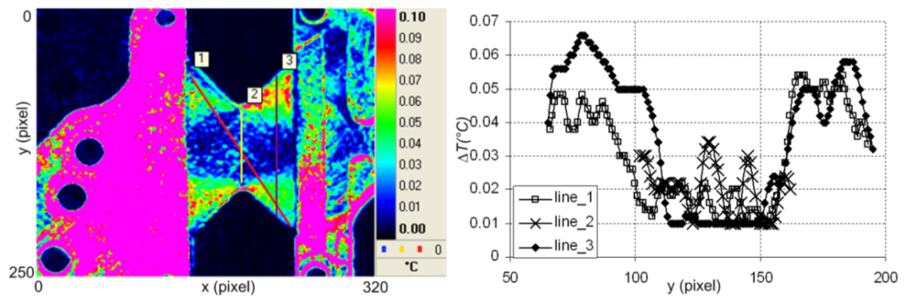

Figure 1: This is the example of a figure.

|  |  |  |  |
| --- | --- | --- | --- |
| Engineering constant |  | Identification | Homogenized model |
| *E*1 | [GPa] | 21.7 | 25 |
| *E*2 | [GPa] | 20.3 | 25 |
| **12 | – | 0.12 | 0.064 |
| *G*12 | [GPa] | 1.55 | 2.7 |
| tan**(*E*1) | – | 0.0051 | – |
| tan**(*E*2) | – | 0.0062 | – |
| tan**(*G*12) | – | 0.0098 | – |

Table 1: This is the example of a table.

For more information about the instructions for the layout of the abstract, please contact Jens Chr. Rauhe.

**Acknowledgement**

The authors of this work gratefully acknowledge Grundfos for sponsoring the 11th MechMan symposium.

**REFERENCES**

[1] K.K. Kratmann, M.P.F. Sutcliffe, L.T. Lilleheden, R. Pyrz and O.T. Thomsen, A novel image analysis procedure for measuring fibre waviness in unidirectional fibre composites, *Composites Science and Technology,***69**, 2009, pp. 228-238 (doi: 10.1016/j.compscitech.2008.10.020).

[2] O. O. Ochoa and J. N. Reddy, *Finite element analysis of composite laminates*, Solid Mechanics and its Applications, Vol. 7, Kluwer Academic Publishers, Dordrecht, 1992.

[3] L. Sorensen, T. Gmür and J. Botsis, Delamination propagation measure­ment using long gauge-length FBG sensors, *Proceedings of the 3rd In­ternational Con­ference on Composites Testing and Model Iden­tifica­tion CompTest 2006 (Eds. P. Camanho, F. Pierron, M. Wisnom), Porto, Portugal, April 10-12, 2006,* University Press, Porto, Paper 41, 2006, pp. 174-175.